Juan Guerrero & Alfayed Baksh (Travis)

Professor Nikhil Yadav

CUS 1194: - Mobile Health (mHealth) Technology

07 March 2017

**Project Design Document**

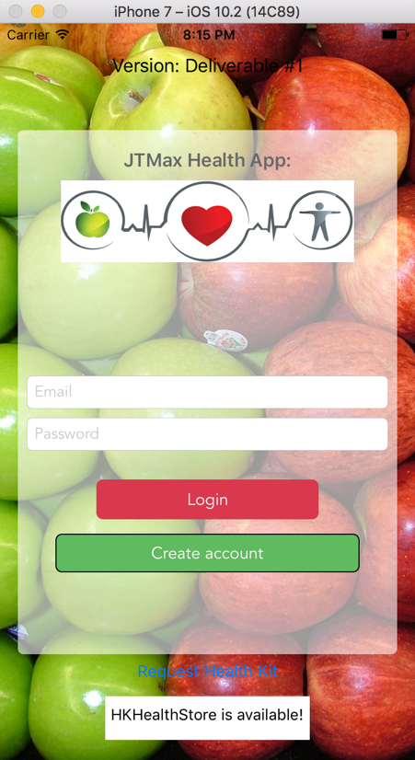The TJMax Health Application is a simple software that helps to keep track of an individual’s overall wellness. This is accomplished by utilizing the iOS components and developer modules to successfully deploy the necessary gadgets to successfully run the app. TJMax Incorporated uses the iPhone’s integrated accelerometer sensor to aid the process of reading someone’s steps that can be used to calculate the total number of calories burnt. We are targeting the population interested in changing their lifestyle. These sample of individuals usually range from 20 to 30 years of age, where there is a tendency to follow a sedentary lifestyle. The application is simple to look at and user friendly. A welcome screen appears and asks to sign in; if the account doesn’t exist, the user can enter credentials are to be added to the authorization in Firebase with the create account button.

Once logged in, a user would be able to look at their individual progress from the start to the current date. This feature allows for a person to understand and analyze personal growth and overall 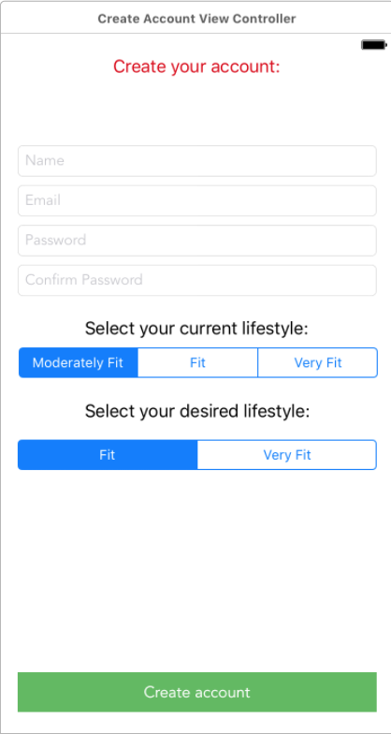physical wellness. The app also contains a section where the user can log in a meal and specify the number of calories taken in so accurate calculations can be performed when using the accelerometer sensor. With the help of Apple’s Health Kit APIs, TJMax Incorporated will be able to reuse essential components that are needed to make such calculations. All this data is stored in Firebase and can easily be accessed by the user at any given time. We have secured the read and write properties of Firebase, so users are only allowed to write data to their own profile, although; we do plan on implementing a social aspect to keep users engaged. If time allows, we will also be allocating a portion of the app to the Ronald McDonald foundation. For their annual runs, users will be able to view a participant’s completion status regarding the activities for the day. We would also be implementing a page dedicated to the foundation that states their current activities and their future goals. A button that will redirect a user to donate will also be implemented.

We are currently focusing development on an iPhone 7, given that the project device iPad does not have “HealthKit.” We will be implementing navigation of our View Controllers through Navigation View Controllers once we’ve had our user logged into the application. We hope to incorporate the HealthKit display functions in our application to aid our user’s understanding of their progress.

*As of now, we are not able to continue implementing our ideas for HealthKit in our application due to the lack of a developer’s license.*